Name: System Maintenance
Use-Case Realization Report (Analysis)
System Maintenance

Issue 3.1
Revision History
Date | Issue | Description | Author
17 July 2000 | 1.0 | First Issue | Howard Russon
26 July 2001 | 2.0 | Revised for MTech Unit 3 in 2001 | Howard Russon
21 July 2004 | 3.0 | Revised for MTech Unit 3 in 2004 | Howard Russon
1 August 2009 | 3.1 | Revised for MTech Unit 3 in 2009 | Heng Boon Kui

Table of Contents
1. Brief Description 4
2. Flow of Events 4
2.1 Standard Flow 4
2.1.1 Log-In 4
2.1.2 User Functions 5
2.1.3 Log-Out 6
2.2 Exceptions 6
3. Interaction Diagrams 7
3.1 Collaboration Diagram: Log-In 7
3.2 Collaboration Diagram: Display Drink Stocks and Prices 8
3.3 Collaboration Diagram: Change Prices 8
3.4 Collaboration Diagram: Display Cash Stocks 9
3.5 Collaboration Diagram: Display Total Cash 9
3.6 Collaboration Diagram: Log-Out 10
4. Participating Objects 10
5. Class Diagrams 12
5.1 Class Diagram: System Maintenance (Main) 12
5.2 Class Diagram: System Maintenance (Stores) 13
6. Derived Requirements 13

Use-Case Realization Report
System Maintenance

Brief Description
The use case enables the Maintainer to perform vending machine maintenance tasks. The Maintainer will be able to monitor the stock levels of brands and coin denominations, view/change the prices of brands and remove all the coins from the vending machine.

Flow of Events
The standard flow of events for this use case and any exceptions are described in the following subsections. The events are described in terms of Actors and Analysis Objects.

Standard Flow
This use case carries out three functions: login-in; user functions to display/change data; log-out. These are described below.

Log-In
The flow of events is shown in section 3.1 and described as follows:
- The Maintainer enters a character string into the Password Box of the Maintenance Panel. When the <return> key is pressed, the PasswordEntered operation of the Password Box will use operation ProcessPassword of the Access Manager to send the password entered for further processing.
- The Access Manager will use operation ValidatePassword of the Password object to send the received password string for validation. Then it will instruct the Password Box to deactivate itself.
- The Password object will compare the received password with the allowed password stored in the object, and returns a response to the Access Manager informing whether the password is valid or invalid.
- If the Password is valid, the Access Manager will use operation LogInValid to instruct the PasswordValidDisplay object to display and flash "PASSWORD VALID" on the Maintenance Panel.
- If the Password is invalid, the Access Manager will use operation LogInInvalid to instruct the PasswordInvalidDisplay object to display and flash "PASSWORD INVALID" on the Maintenance Panel. The Password Box will then be instructed to become active.
- Upon a successful log-in, the Access Manager will inform the Maintenance Controller using operation MaintainerLogin. The following activities will then be performed:
- Activate the Maintenance Panel so that its constituent objects (Coin Display, Drink Display, Price Display, Total Cash Display, Exit Button, Transfer Cash Button, PasswordInvalidDisplay, Total Cash Button) are available to the Maintainer by using operation Activate of the Maintenance Panel. In turn, the constituent objects will be activated by using their respective Activate operations.
- Instruct the Door object to set the door status to "open" (using operation SetState).
- Instruct the Store Controller to display the new Door status on the Door Status Display by using operation DisplayDoorStatus. To achieve this, the status is determined by using operation GetState (of Door) and then it is displayed by using operation Update of the Door Status Display.
- Instruct the Store Controller to activate the Machinery Simulator Panel for user input by using operationActivateDisplay. This in turn uses operation ActivateDisplay of Machinery Simulator Panel, which uses the Activate operation of ewach of its sub-objects.
- Next, the Maintenance Controller will instruct the Simulator Control Panel to deactivate the Activate Customer Panel Button, if the Customer Panel is not active. For this, the Deactivate operation of the Activate Customer Panel Button will be used.
- Finally, the Maintenance Controller will use operation TerminateTransaction (of the Transaction Controller) to terminate and suspend Customer transactions (this operation is described in use case Coin Input and Select Brand).

User Functions
The flow of events is shown in sections 3.2-3.5 and the functions are described in the following sections:

Display Drink Stocks and Prices
If the Maintainer presses a button on the Drink Display in the Maintenance Panel, the GetStock operation of the Drink Display will instruct the Maintenance Controller to display the drink stock and drink price corressponding to the brand button pressed by the maintainer. For this, operations GetStock and GetPrice of the Maintenance Controller are used.

To get the stock available of the selected brand (operation GetStock of Maintenance Controller), the following will be performed:
- Operation GetItem of Drinks Store will be used to return a reference to the Drink Store Item that corresponds to the selected brand.
- Operation GetQuantity of Drink Store Item will be used to get the stock level of the selected brand.

To get the price of the selected brand (operation GetPrice of Maintenance Controller) the following will be performed:
- Operation GetItem of Drinks Store will be used to return a reference to the Drink Store Item that corresponds to the selected brand.
- Operation GetBrand of Drink Store Item will be used to return a reference to the Drinks Brand.
- Operation GetPrice of Drinks Brand will be used to get the price of the brand.

Upon receiving the values for display, the Maintenance Controller will use operation DisplayPrice of Price Display and operation DisplayStock of Drink Display to complete the task.

Change Prices
If the Maintainer changes the price of a drink using the Price Display on the Maintenance Panel, the ChangePrice operation of the Price Display will instruct the Maintenance Controller to change the price of the drink brand (that is currently selected by the maintainer) by using operation SetPrice of the Maintenance Controller. The Maintenance Controller will in turn use the following operations:
- Operation GetItem of Drinks Store will be used to return a reference to the Drink Store Item that corresponds to the selected brand.
- Operation GetBrand of Drink Store Item will be used to return a reference to the Drinks Brand.
- Operation SetPrice of the Drinks Brand will be used to set the new price.

Display Cash Stocks
If the Maintainer presses a button (coin selection) on the Coin Display, then operation GetQuantity of the Coin Display will instruct the Maintenance Controller to return the total amount of cash held of the selected coin denomination for display. For this, operation GetCoinTotal of the Maintenance Controller will be used. The GetCoinTotal operation of the Maintenance Controller will undertake the following:
- Use operation FindDenomination of the Cash Store to locate the Coin object of the desired denomination.
- Use operation GetQuantity of the selected Coin to get the total number of coins held.

The resulting value will be returned to the Maintenance Panel for display.

Display Total Cash
If the Maintainer presses the Total Cash Button, the Maintenance Panel will use operation GetTotalCash of the Maintenance Controller. The Maintenance Controller will use operation TotalCash of Cash Store to obtain the total cash held in the vending machine. This will be calculated as follows:
- Operation GetValue of each Coin will be used to determine the value of each denomination.
- Operation GetQuantity of each Coin will be used to find the quantity of each denomination held in the machine.
- The total cash value will be calculated by summing the products of values and quantities.

Then operation DisplayTotalCash of the Total Cash Display will be used to display the total cash value.

Transfer All Cash
If the Maintainer requires to collect all the cash held in the Cash Store, then he presses the Transfer Cash Button on the panel. This maintenance operation is described under Transfer All Cash use case.

Log-Out
The flow of events is shown in section 3.6 and described as follows:
- When the Maintainer presses the Exit Button on the Maintenance Panel, operation Exit of the Exit Button will trigger the operation MaintainerLogout of the Maintenance Controller to process the exit request.
- The Maintenance Controller will check the door status attribute of Door to determine (using operation GetState) whether the vending machine door is locked. If the Door is unlocked then the exit request is ignored.
- The Maintenance Controller will then complete the log-out procedure by re-setting the Maintenance Panel by using operation Deactivate. This involves deactivating the Coin Display, Drink Display, Price Display, Total Cash Display, Exit Button, Transfer Cash Button, PasswordInvalidDisplay, PasswordValidDisplay, and Total Cash Button. The Deactivate operations of the respective objects will be used to accomplish this. ThePassword Box will then be enabled by using its operation Activate.
- If the Customer Panel is currently active, the Maintenance Controller will use operation UpdateDrinkSelection of the Dispense Controller to update the drink brands being dispensed and their prices on the Drink Selection Box. For each Drinks Brand, this operation will do the following:
- Use operation GetStock of the Drinks Store to find the current stock level of the brand.
- Use operation GetPrice of the Drinks Store to find the price of the brand.
- Use operation Update of Drink Selection Box to display NO STOCK messages and drink prices on the Drink Selection Box.
- If the Customer Panel is not active, the Maintenance Controller will instruct the Simulator Control Panel to activate the Activate Customer Panel Button. For this operation Activate of Activate Customer Panel Button will be used.
- The Maintenance Controller will then use operation AllowSelection of the Dispense Controller to activate the Drink Selection Box so that further Customer transactions can take place. This is achieved for each brand as follows:
- Operation GetItem of Drinks Store will be used to get a reference to the Drink Store Item that corresponds to the brand.
- Operation GetQuantity of Drink Store Item will be used to determine the current stock level of the brand.
- Operation SetState of the Drink Selection Box will be used to activate or deactivate the buttons according to the stock level.
- The Maintenance Controller will then instruct the Change Giver to activate the NO CHANGE AVAILABLE display, if necessary by using operation DisplayChangeStatus of the Change Giver.
- To achieve this, firstly operation GetChangeStatus of Cash Store will be used to determine the change status. This will be done by:
- Determining the number of Coins held of each denomination by using operation GetQuantity of Coin for each denomination.
- Using a set of criteria (to be defined) to determine whether "enough" change is available.
- Then, operation DisplayNoChange of No Change Available Display will be used to display the appropriate message on the Customer Panel.

Exceptions
The following exceptions have been identified:
- Door Not Locked. If the vending machine Door is un-locked, then the Maintainer is not permitted to formally log-out. This is covered under Log-Out in section 2.1.

Interaction Diagrams

Collaboration Diagram: Log-In
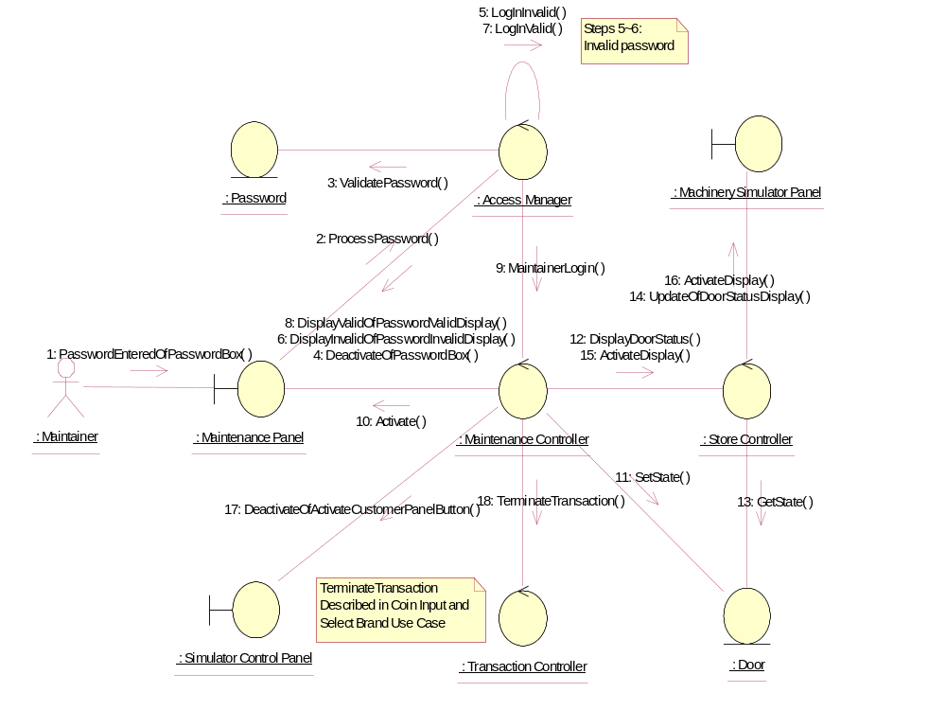

Collaboration Diagram: Display Drink Stocks and Prices
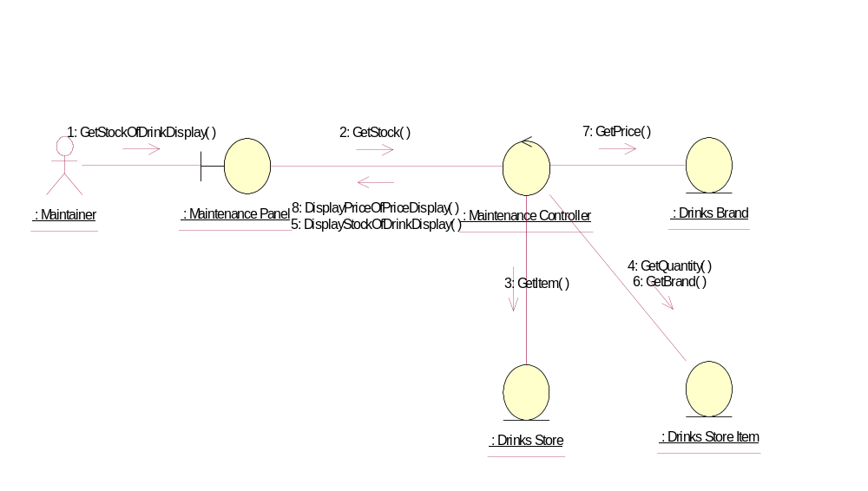

Collaboration Diagram: Change Prices
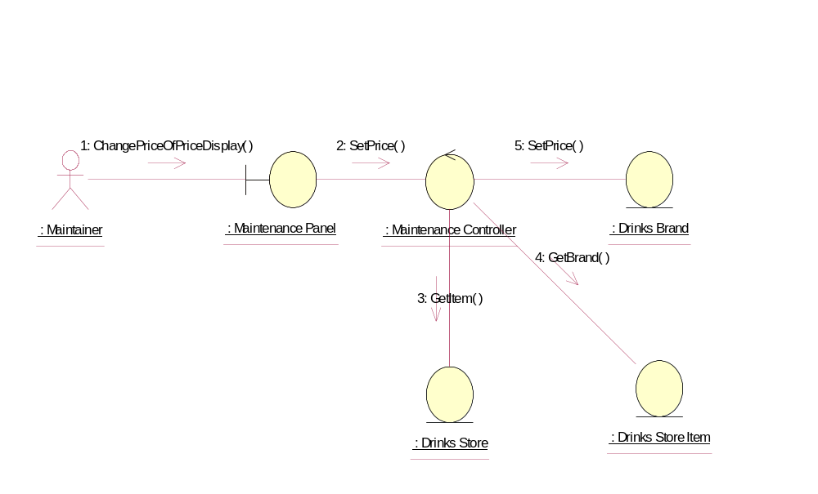

Collaboration Diagram: Display Cash Stocks
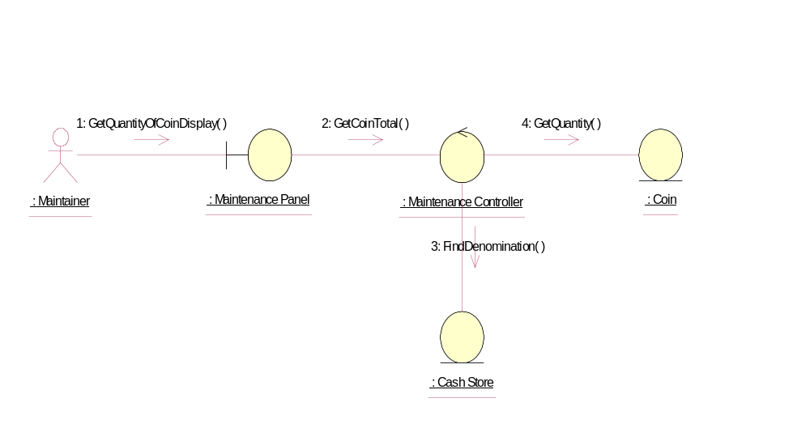

Collaboration Diagram: Display Total Cash
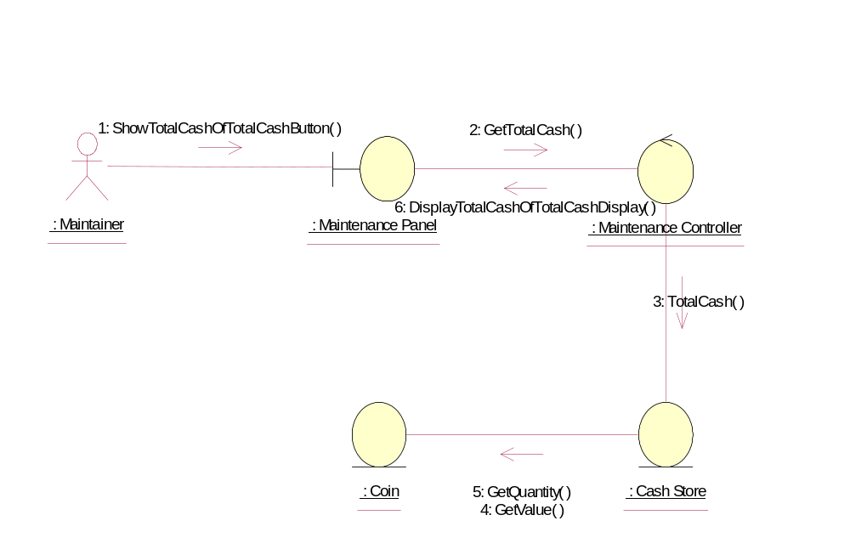

Collaboration Diagram: Log-Out
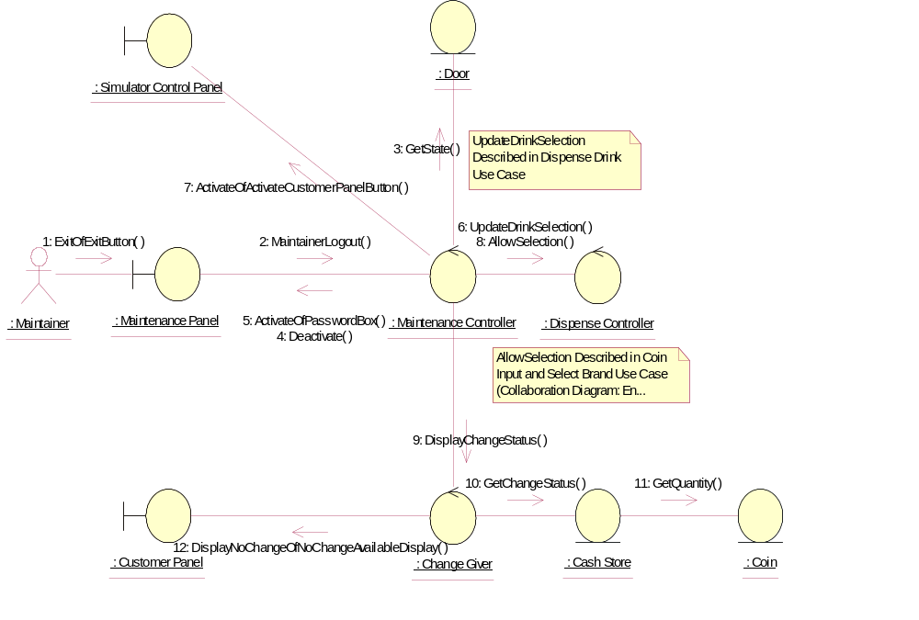

Participating Objects
: Access Manager
This control object manages and controls entry to the system by the Maintainer.
: Cash Store
This object represents the store of cash in the vending machine.
: Change Giver
This control object manages the giving of change to the Customer.
: Coin
This object stores the weight and value of each type of Coin, and hence enables the machine to recognise each Coin entered.
: Customer Panel
This panel simulates the vending machine's customer interface panel. It will enable the user (the Customer) to:
1 insert coins;
2 select brands;
3 terminate transaction.
It will also provide the following display functions:
1 display total money inserted;
2 indicate coin not valid;
3 indicate no change available;
4 display the value of the change to be collected;
5 display an icon representing the dispensed drink.
: Dispense Controller
This control object is for handling the dispense drink use case.
: Door
This object represents the door of the vending machine. It is opened so that the machine can be restocked with cans and cash.
: Drinks Brand
This entity object stores the name of the drink brand and it's price. There can be as many drink brands as we desire, for a particular configuration.
: Drinks Store
The object is storage, in the vending machine's memory, for the total number of cans of each Drinks Brand held by the vending machine.
: Drinks Store Item
This represents a column of drinks in the vending machine. It can store a drink of any particular brand type.There can be as many drink store items as we desire in the vending machine. This number will be a configurable item for the vending machine.
: Machinery Simulator Panel
This panel simulates the physical actions of the maintainer. It enables the user to:
1 display and enter new values for the number of cans of each Drinks Brand held by the Drinks Store;
2 display and enter new values for the number of Coins of each denomination held by the Cash Store;
3 display whether the vending machine Door is unlocked, and enable it to be locked.

: Maintainer
This actor represents the vending machine maintainer who will have a simple display panel to enable stock levels of drinks-cans and change to be monitored, and to enable cash within the machine to be collected.
: Maintenance Controller
This control object handles the system maintenance use case.
: Maintenance Panel
This panel simulates the vending machines maintainer control panel. It will enable the user (the Maintainer) to:
1 log-on using a password;
2 display number of Coins of each denomination in the Cash Store;
3 display total value of cash in the system;
4 display number cans of each Drinks Brand held in the Drinks Store;
5 change the price of any Drinks Brand;
6 collect all cash held in system;
7 formally exit from the panel.
: Password
This entity object stores the correct password.
: Simulator Control Panel
This panel is displayed when the system is started up. It enables the user (the Controller) to :
1 start (switch on);
2 stop (switch off);
3 activate the customer panel;
4 activiate the maintenance panel;
5 activate the machinery simulator panel.

: Store Controller
This object controls the Change State use case. It mangages changes in Cash Store attributes and the Drinks Store attributes. It also handles the door status. It is also used by the Dispense Drink use case to update the Drinks Store attributes.
: Transaction Controller
This control object coordinates the customer transactions for selection of a drink brand, coin input, storage of coins and termination requests for ongoing transactions.

Class Diagrams

Class Diagram: System Maintenance (Main)
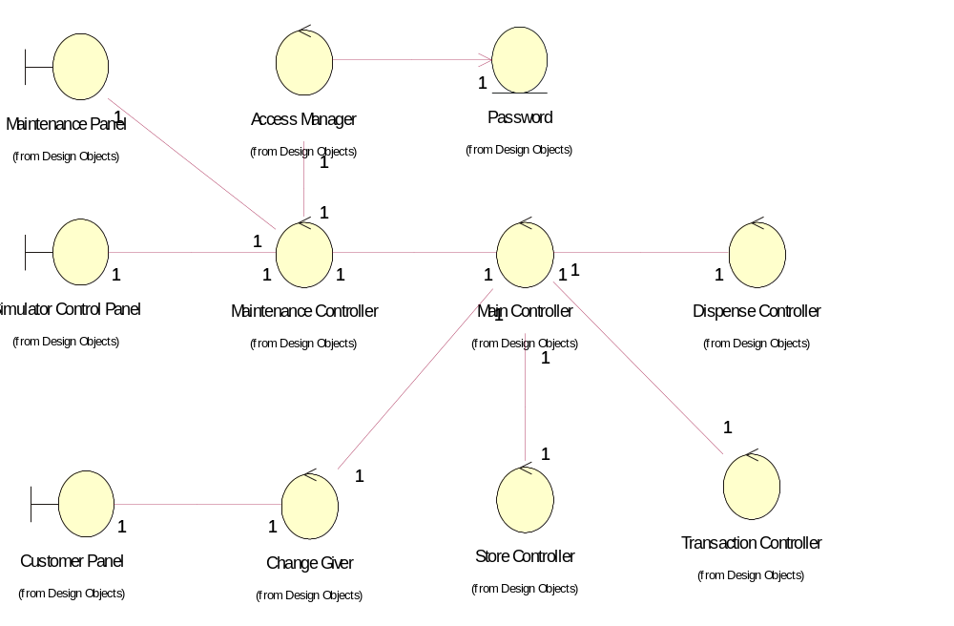

Class Diagram: System Maintenance (Stores)
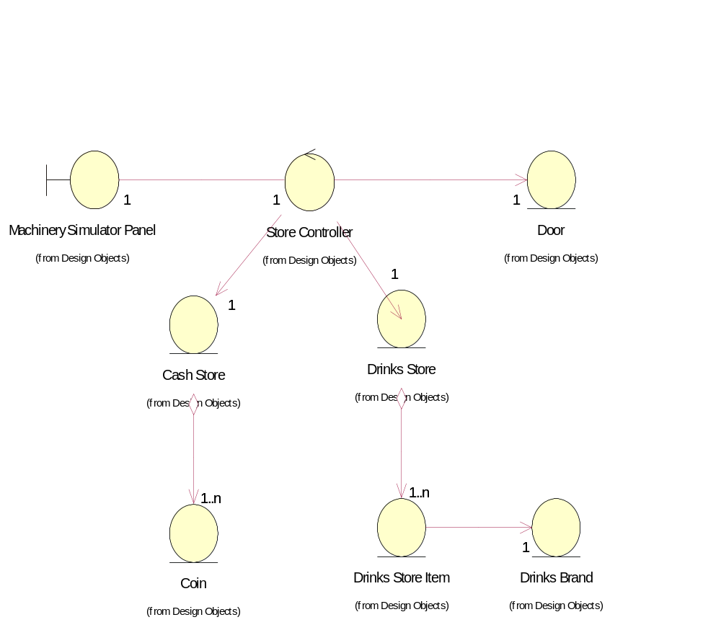

Derived Requirements
The PC mouse and keyboard will be used to enable the Password and new prices to be entered.

